Frozen Service Lines
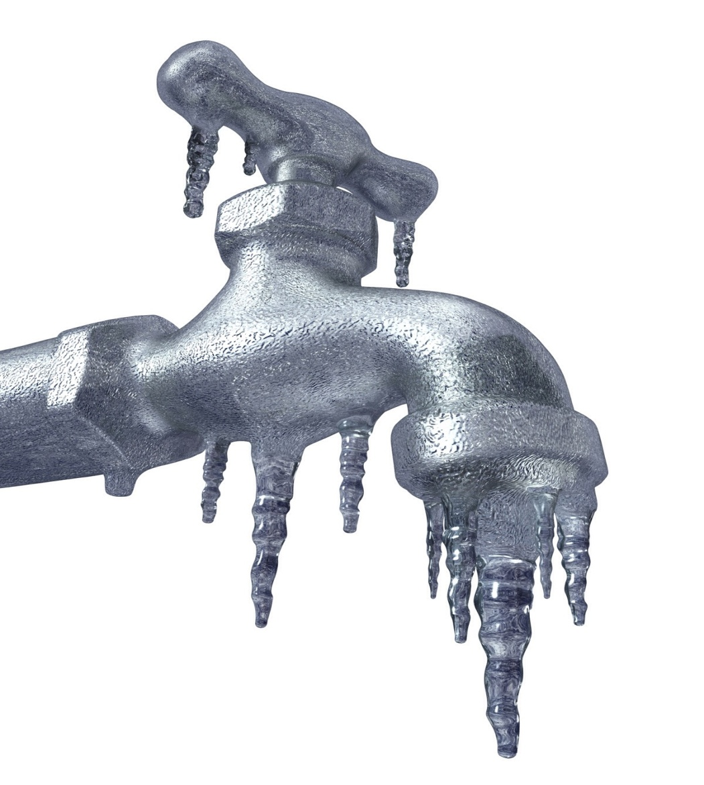
Frequently Asked Questions
PLEASE NOTE!
Running water may increase your water bill

REDUCE THE RISK OF FROZEN PIPES
Leave a cold water tap running at a
steady stream of about 1/4 in.
- Leave the cupboard doors open under your kitchen and bathroom
- Do not turn your furnace below 55° F
- Shut off and drain the pipes leading to outside faucets
- Wrap foam insulation around pipes most susceptible to freezing
- Seal air leaks in your home and garage
- If you are away, have someone check your home regularly
Frequently Asked Questions:
Q. I think my service line is frozen.
What should I do?
A. Contact the LPRW office.

Q. Does the LPRW thaw service lines?
A. No, but it is important to let LPRW know that your service line is frozen.

Q. Does the LPRW give a credit or reimburse for the water if we let our facets run?
A. No, the LPRW does not give a discount for the
water use. All water going through the water
meter will be billed.

Q. How much does it cost to thaw a service line?
A. The price varies by contractor. The minimum
fees are running around $400.

Q. How much does it cost to Let It Run!?
A. It will cost homeowners around $1 a day to Let
It Run! It is the best insurance policy available.

Q. How can I tell if my water line is freezing?
A. Some people have been given no warning at
all. Some people see a drop in water pressure
before the line freezes.

Q. If my neighbor freezes, should I run my water?
A. LPRW strongly encourages you to let your water run if your neighbor or someone close by you freezes. The lack of movement can cause problems for neighborhoods.

